2025 Renewable Energy Symposium
Speakers

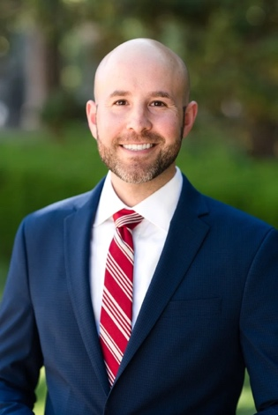
Panel 1: Legislative Update
Matt Klopfenstein | Co-Founder & Partner, Summit Advocacy
Matt Klopfenstein represents a variety of clients in legislative and regulatory arenas, specializing in technology, energy, environmental, transportation, manufacturing, and local government policymaking. He covers a wide breadth of high-profile issues for clients, serving as both a subject matter expert and boots-on-the-ground lobbyist. He has been involved in numerous noteworthy policy fights, both sponsoring priority legislation for clients, as well as working to prevent problematic proposals. Matt has extensive experience across a broad range of policy issues, including utility and renewable energy issues, critical minerals development, technology and privacy policies, business and litigation issues, and CEQA.
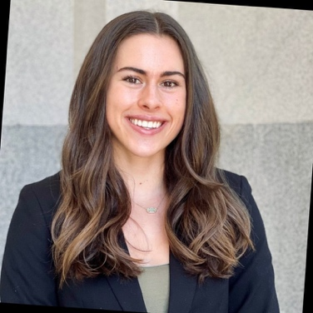
McKinley Thompson-Morley | Principal, Seaside Advocacy, LLC
McKinley Thompson-Morley has nearly a decade of experience working in state and local government affairs, policy and advocacy. McKinley’s experiences span a wide range of issues, including energy, circularity, business continuity, transportation, infrastructure and more.
Prior to joining Seaside Advocacy, McKinley was an advocate at California Advisors, LLC, where she represented diverse clients in the business, technology, energy and local government spaces. Previously, McKinley represented Gap Inc. at the state and local level, developing internal advocacy strategy and providing policy analysis and government affairs across California, Arizona, Washington, Tennessee and Ohio. She secured policy wins related to textile recycling, organized retail crime, and workforce.
McKinley also spent several years in the state Senate, as a Senate Fellow and legislative staffer. During this time, McKinley developed a deep knowledge of the legislative process, stakeholders and key issues. She worked directly on policy related to local government, infrastructure, energy, transportation, housing and education.

Panel 2: Lunch with the Lawyers: Panel of Attorneys Discuss Renewable Energy Permitting Processes
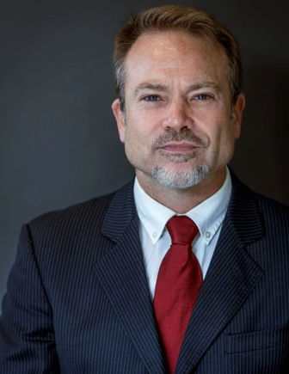
Ian Michael Forrest, Esq. | Founder & Managing Partner, Forrest Environmental Law
Ian leverages over 25 years of experience navigating diverse and unique regulatory challenges in support of a wide range of development projects and matters, including the development of real estate, renewable energy and infrastructure, regulatory compliance, as well as administrative and environmental litigation.

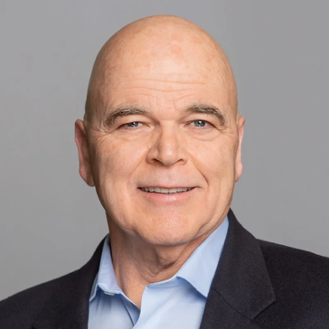
Jeffery Harris | Climate Edge Law Group
Jeff Harris draws on more than three decades of experience to advise his private and public sector clients on all facets of California energy law. His experience provides a unique understanding of the legal, political, and regulatory interplay of energy markets, regulation, law and policy. While his practice is diverse, Jeff focuses on developing permitting plans for complex, multi-jurisdictional energy generation and storage projects. He excels in developing and implementing strategies for the permitting, construction and operation of renewable and conventional powerplants and a diverse array of energy storage technologies.
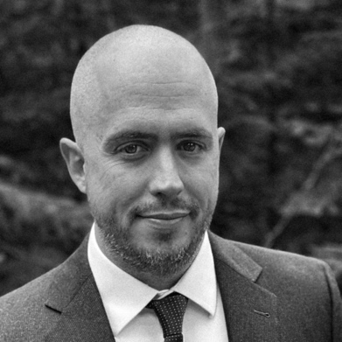
Zachary Kearns | Partner, Bell Kearns LLP
Zachary Kearns is a partner at Bell Kearns LLP, where he focuses his practice on advising energy companies and other businesses on land use and environmental permitting matters. Informed by his broad litigation experience, he helps project proponents craft legal strategies and environmental impact disclosure documents that will not just survive legal challenges but deter them. Zak’s practice centers around the National Environmental Policy Act (NEPA), the California Environmental Quality Act (CEQA), the Endangered Species Act, and other federal, state, and local environmental and land use laws. In addition to guiding clients through the legal thickets of land use law, Zak has also successfully represented plaintiffs and defendants in state and federal courts in a variety of environmental and commercial disputes.

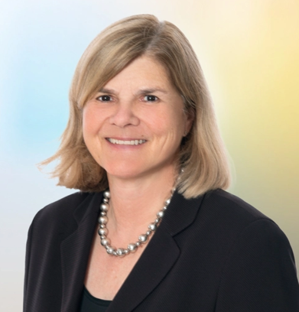
Annie Mudge | Partner, Cox Castle
Anne ("Annie") is one of California's leading siting and permitting lawyers for land use development and utility-scale renewable energy projects. She has been recognized as one of Daily Journal’s Top 100 Lawyers in California and has been named among the Top 50 Women Lawyers in Northern California multiple years running. In 2025, the Daily Journal named Annie one of California's Top Real Estate and Development Lawyers. She is a recognized leader in the permitting of renewable energy facilities, and she is a frequent speaker and presenter on renewable energy issues.

Lunch Keynote: Lake Effect or Data Mirage? How accounting for technology differences at utility scale solar energy facilities can change fatality data interpretation
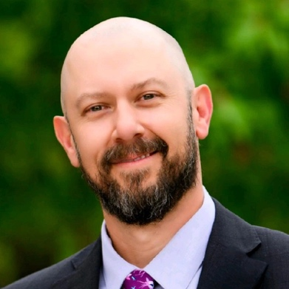
Karl Kosciuch, PhD | Wildlife Program Manager, TetraTech
Karl Kosciuch is working at the intersection of energy development and wildlife issues with excellence in science, permitting, project management, client management, and staff management. His expertise spans existing and emerging renewable and conventional energy technologies integrating novel risk and impact assessment analyses for wildlife and other natural resources. He published 21 peer-reviewed papers and has presented at over 24 professional meetings.
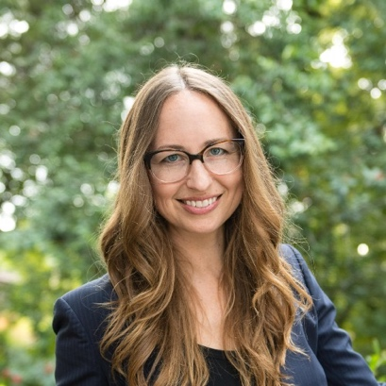
Marisa Mitchell | Head of Environmental & Permitting, Intersect Power
Marisa Mitchell is head of Environmental & Permitting at Intersect Power, where she leads environmental siting, permitting, and compliance of large and complex energy infrastructure projects primarily in the western US and great plains. As a former CEQA and NEPA contractor for public agency clients, and as a renewable energy developer since 2013, Marisa brings her understanding of both public and private sector needs and objectives to her passion for helping to craft streamlined permitting solutions that achieve society's environmental goals, particularly in California. Marisa has a BS in Environmental Science (UC Berkeley), an MA in Environmental Studies (UC Santa Cruz), and an MBA (UC Berkeley, Haas).

Panel 3: BESS(t) Practices: How to Permit BESS Projects
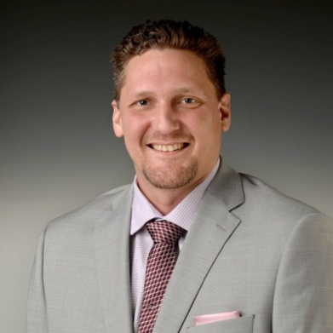
Josh Adams | Energy Storage Engineering Manager, NextEra Energy Resources
Josh Adams is an energetic, charismatic, and results-oriented innovator with extensive technical leadership experience and a diverse educational background. Growing up in the Pacific Northwest, Josh developed a deep love for nature and a strong desire to preserve our beautiful world. This passion for making a positive global impact inspired him to pursue a master’s in renewable energy engineering. Josh’s expertise spans several key areas, including energy-efficient building systems, thermal management, battery energy storage system (BESS) integration, codes and standards, and BESS fire safety systems. His commitment to sustainability and innovation continues to drive his work, making him an asset in the field of renewable energy.
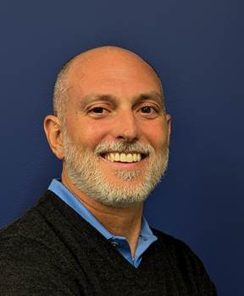
John Bellas | CEQA Technical Director, Michael Baker International
John Bellas is Michael Baker International’s CEQA Technical Director for the Los Angeles area. With 25 years of experience, he has managed the preparation of numerous CEQA and NEPA documents for a wide range of projects, including renewable energy projects, urban infill projects, greenfield and brownfield development projects, schools and colleges, parks and recreational facilities, land use plans and programs, and various capital improvement projects. In addition, John regularly provides strategic CEQA guidance to a variety of agencies in Southern California and frequently conducts peer reviews of CEQA documents for lead and responsible agencies. John is also an experienced CEQA instructor, having conducted specialized CEQA training programs for agencies and served as a panelist for CEQA training sessions hosted by professional organizations.
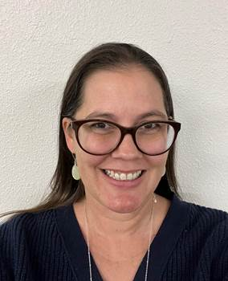
Anastasia Shippey | Senior Planner, Sacramento County Planning & Environmental Review
Anastasia has worked as an environmental planner for the past seven years. Working as a consultant on a variety of projects including transportation, development, and restoration before joining the County of Sacramento. Since joining the County in early 2024, Anastasia has worked as the environmental analyst on several different projects including being a lead person for the environmental review of the first stand-alone Battery Energy Storage System (BESS) in the County. Anastasia has also been part of several pre-application meetings for other BESS projects and is continuing to expand her knowledge of the environmental review of these facilities.Panel 4: Fed Up: Renewable Energy Developer Round Table Discussing Federal Implications & Updates in Permitting Renewable Energy
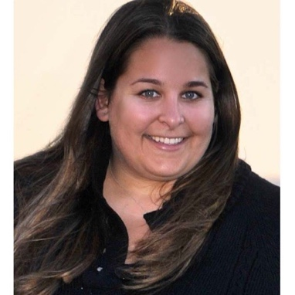
Moderator
Corinne Lytle Bonine | Director, Permitting - Wind, Permitting and Real Estate – West, AES Clean Energy
As the Permitting Director for Wind and the Western United States at AES Clean Energy, Corinne Lytle Bonine leverages over 18 years of environmental permitting experience to help the transition to clean, renewable energy. Corinne Lytle Bonine has managed an array of National Environmental Policy Act (NEPA) and California Environmental Quality Act (CEQA; including CEQA-equivalency and adjudicated CEQA processes) processes including Environmental Impact Statements, Environmental Impact Reports, Applications for Certification to the California Energy Commission, Coastal Development Permits, Environmental Assessments, and Initial Study/Mitigated Negative Declarations, exemptions/exclusions. Her experience includes a variety of development projects, but her passion and focus has been on environmental permitting and compliance for utility-scale renewable and low-carbon energy and transmission projects. Her permitting projects include but are not limited to Endangered Species Act Sections 7 and 10 consultations, Eagle Take Permits, USACE Individual Permits, and Section 106 consultation and Programmatic Agreements. She was honored to serve on the Technical Advisory Committee for the County of San Diego’s Comprehensive Renewable Energy Plan and has been elected as the administrative Vice President for the Association of Environmental Professionals.
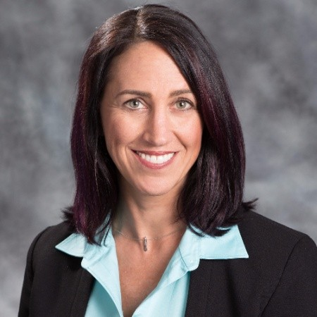
Theresa Carroll | Vice President, Environmental Policy and Compliance, AES Clean Energy
Theresa Carroll is the Vice President of Environmental Policy and Compliance at AES Clean Energy, where she leads a team of permitting and environmental compliance experts. She has extensive expertise in environmental policy as well as state and federal endangered species permitting strategies across the United States. With over two decades of experience in environmental permitting, policy development, and construction environmental compliance, Ms. Carroll is widely regarded within the industry. She has significantly shaped the permitting landscape with her comprehensive knowledge of renewable energy project development and construction. Her longstanding membership in national trade associations such as ACP, SEIA, LSA, REWI, and others has contributed significantly to the advancement of utility-scale renewable energy initiatives across the U.S.

Erek DeVost | Vice President – Solar Development, Terra-Gen LLC
Prior to joining Terra-Gen in 2024, Erec DeVost served as Vice President of Permitting for Avantus, managing the permitting and development of a 50 GW development pipeline that spanned from California, across the desert southwest, to Texas. Erec was instrumental in establishing the Onyx Ranch Conservation Project in Kern County, CA where he worked with the Bureau of Land Management, California Department of Fish and Wildlife, and the US Fish and Wildlife Service to implement landscape-level conservation funded by solar energy development. He continues to focus on developing renewable energy projects and unique conservation strategies for Terra-gen.
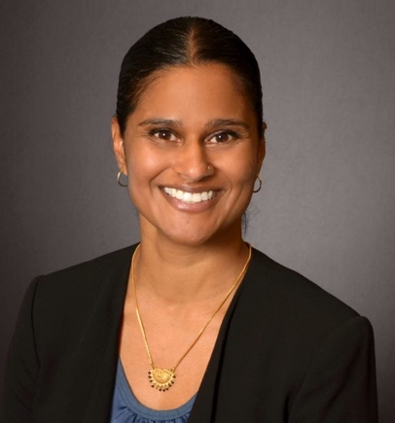
Aarty Joshi | Director, Environmental Permitting, Clearway Energy Group, LLC
Aarty leads a team of permitting professionals who are responsible for securing discretionary land use and environmental permits for Clearway’s portfolio of wind, solar, and energy storage projects. Aarty’s team is also responsible for completing environmental diligence and surveys prior to construction in accordance with local, state, and federal regulations. Aarty has led environmental diligence and permitting activities on close to 5 GW of renewable energy projects on private, state, and federal lands in the US.
Marisa Mitchell | Head of Environmental & Permitting, Intersect Power
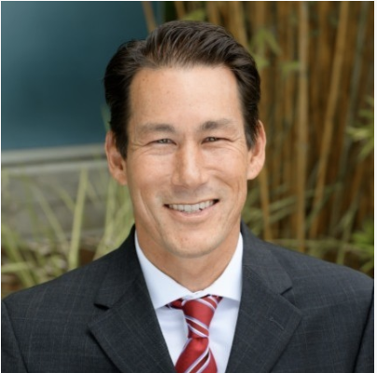
Marisa Mitchell is head of Environmental & Permitting at Intersect Power, where she leads environmental siting, permitting, and compliance of large and complex energy infrastructure projects primarily in the western US and great plains. As a former CEQA and NEPA contractor for public agency clients, and as a renewable energy developer since 2013, Marisa brings her understanding of both public and private sector needs and objectives to her passion for helping to craft streamlined permitting solutions that achieve society's environmental goals, particularly in California. Marisa has a BS in Environmental Science (UC Berkeley), an MA in Environmental Studies (UC Santa Cruz), and an MBA (UC Berkeley, Haas).
Devon Muto | Senior Director of Development, EDF power supply
Devon Muto is a Senior Director of Development responsible for overseeing the development on EDF’s utility scale solar and storage projects in their west region. Since joining EDF Renewables in 2018, he has assisted with advancing over 2 GW of projects to construction while also supporting a pipeline to continue production in the coming years. Mr. Muto currently sits on the Executive Committee of the Renewable Energy Wildlife Research Fund and is also an active member of the Avian Solar Work Group. Prior to joining EDF Renewables, Mr. Muto’s 20+ year career covered several roles in the field of planning and environmental policy including Chief of Advance Planning for the County of San Diego, San Diego Branch Manager for ICF, and project manager for planning and environmental services on several large-scale utility contracts and public projects.

